health care analysis project using Hiveql and pyspark sql

HIVE
Apache Hive is an open-source data warehouse system built on top of Hadoop. It allows you to query and manage large datasets using SQL-like language (HiveQL).

Key Points
- Works with HDFS and converts queries into MapReduce, Tez, or Spark jobs.
- Best for batch processing and data analytics, not real-time queries.
- Stores metadata in a Metastore.
- Commonly used for ETL, reporting, and big data analysis.

Steps for analyzing problems using HiveQL

Access CloudxLab
- Open cloudxlab.com
- Click on MyLab
- Open Jupyter

Upload Dataset
- Click on Upload button
- Upload data.csv from your local health care folder

Load Data into HDFS
#JUPYTER
- !hdfs dfs -mkdir -p /user/cloudxlabusername/medicine
- !hdfs dfs -put Medicine.csv /user/cloudxlabusername/medicine/
- #check whether file uploaded to HDFS or not
- !hdfs dfs -ls /user/cloudxlabusername/medicine/
open WEB CONSOLE CLOUDXLAB
- go to hive
- Create table with your column names
- CREATE EXTERNAL TABLE medicine_data( medicineID INT,companyName STRING,productName STRING,description STRING,substanceName STRING,productType STRING,taxCriteria STRING,hospitalExclusive STRING,governmentDiscount STRING,taxImmunity STRING,maxPrice DOUBLE) ROW FORMAT DELIMITED FIELDS TERMINATED BY ','STORED AS TEXTFILE LOCATION '/user/cloudxlabusername/medicine/' TBLPROPERTIES("skip.header.line.count"="1");
- Describe table
>> DESC medicine_data;
- Store cleaned data into new table
>> CREATE TABLE medicine_clean as
SELECT
medicineID INT,
companyName STRING,
productName STRING,
description STRING,
substanceName STRING,
productType STRING,
taxCriteria STRING,
hospitalExclusive STRING,
governmentDiscount STRING,
taxImmunity STRING,
maxPrice DOUBLE
From medicine_data
Where medicineID is NOT NULL
AND description IS NOT NULL
AND productName IS NOT NULL;

- Enable hive properties
>> SET hive.exec.dynamic.partition = true;
>> SET hive.exec.dynamic.partition.mode = nonstrict;
>> SET hive.vectorized.execution.enabled = true;
>> SET hive.vectorized.execution.reduce.enabled = true;
- Dynamic partitioning
(hive.exec.dynamic.partition, hive.exec.dynamic.partition.mode) controls how Hive writes data into partitions when inserting.
- Vectorized Execution
(hive.vectorized.execution.enabled, hive.vectorized.execution.reduce.enabled) controls how Hive reads/processes data in batches for faster query execution.

User Story: No of Households per disease
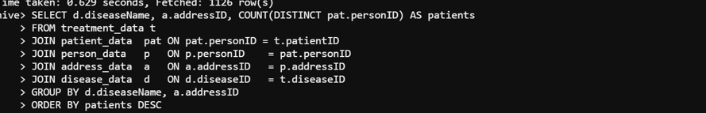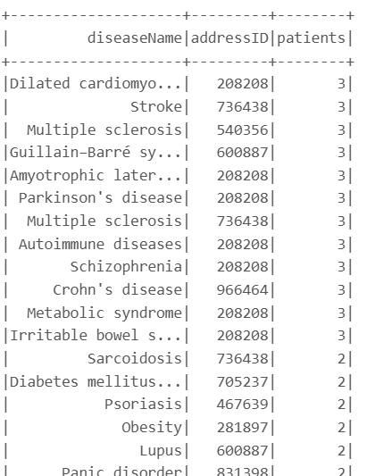

Pyspark SQL:
PySpark SQL is Spark’s structured data module. It provides:
- A DataFrame API (Pythonic, column-based, optimized by Catalyst & Tungsten).
- A SQL interface (register DataFrames as temp views and run SQL queries).
- Integrations with storage formats (Parquet, ORC, JSON, CSV) and catalogs.
Use PySpark SQL when you need analytics, joins, aggregations, window functions, or integrate Python with SQL, all at a cluster scale.

User story:
Create a PlacesAdded table (placeID, placeName, placeType, timeAdded) and update it via a trigger whenever a new city or state is inserted into the Address table.
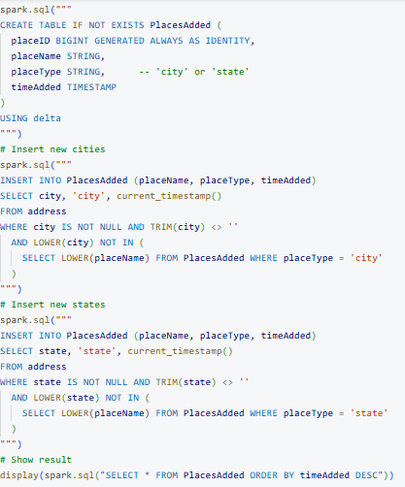
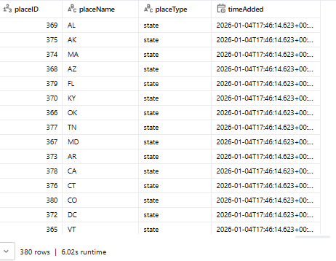

User story:

Find, for each city in Alabama (AL), the disease with the maximum number of patients treated.
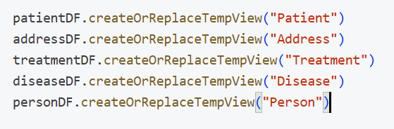
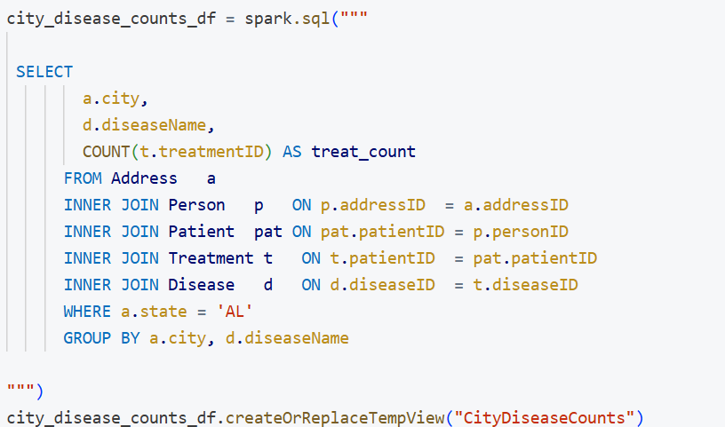
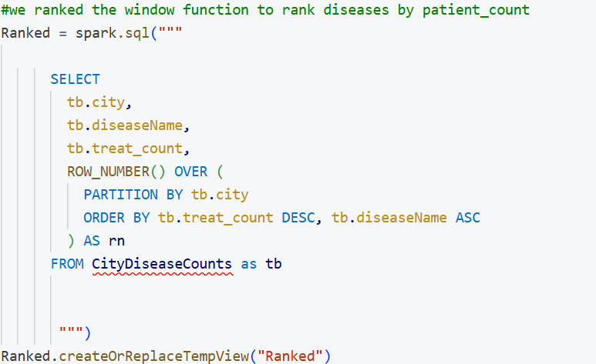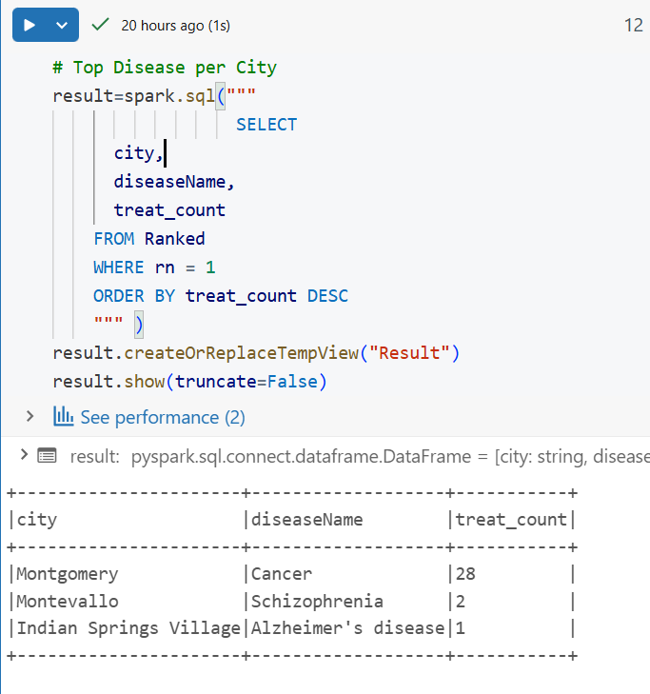

User story:

Find, for each disease, the number of households with more than one patient having that disease.
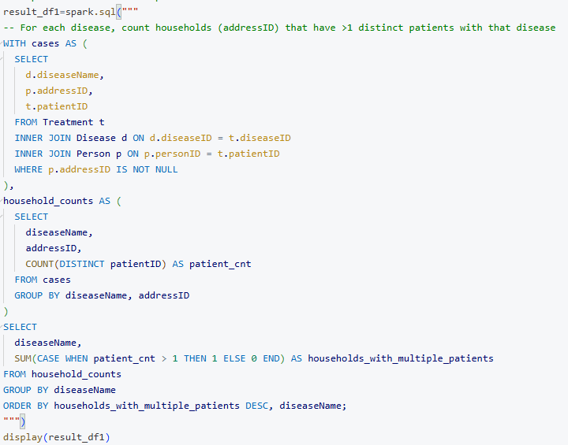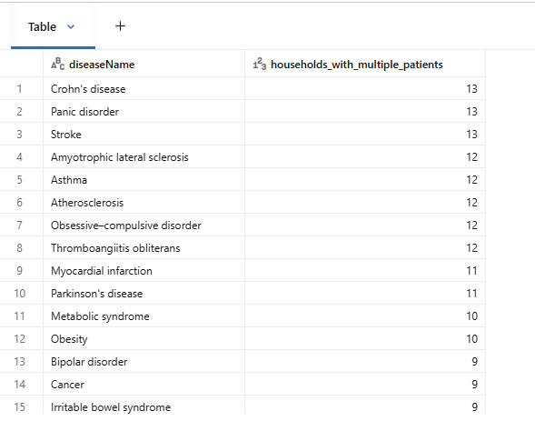

User story:
Write a SQL query to show medicines with product types in words, filtered by tax category
- Tax Category I → Only medicines with product types 1, 2, 3
- Tax Category II → Only medicines with product types 4, 5, 6

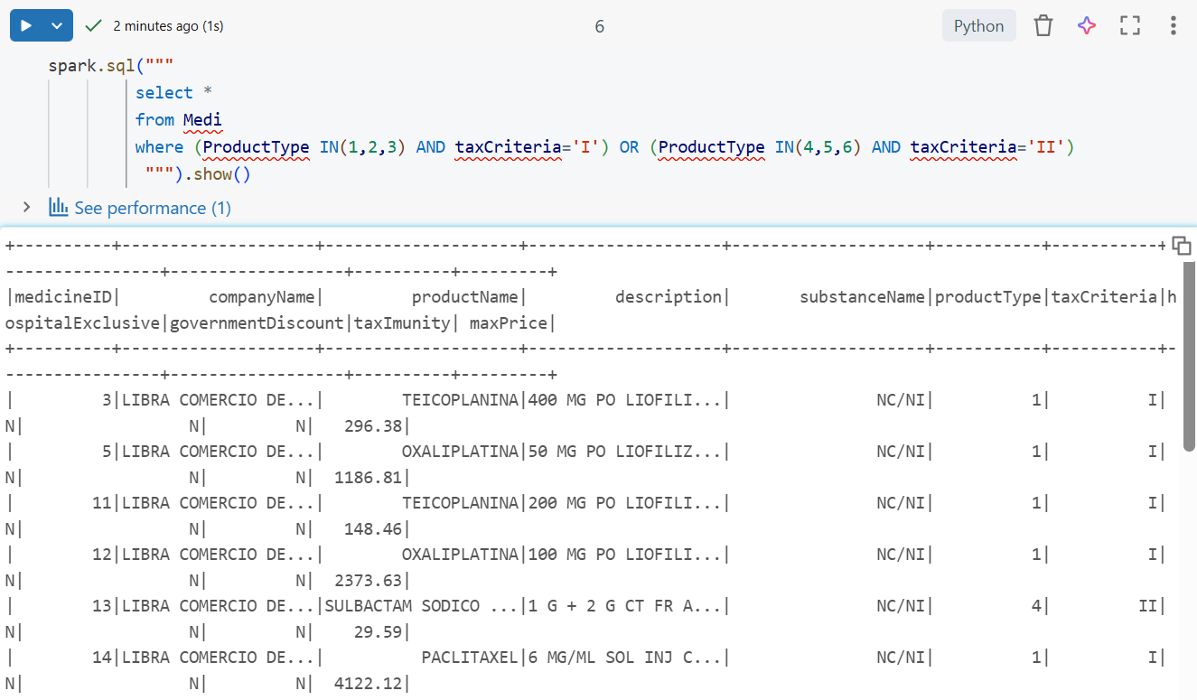

User story:
Find the total medicine quantity per prescription for Ally Scripts and tag as low, medium, or high.
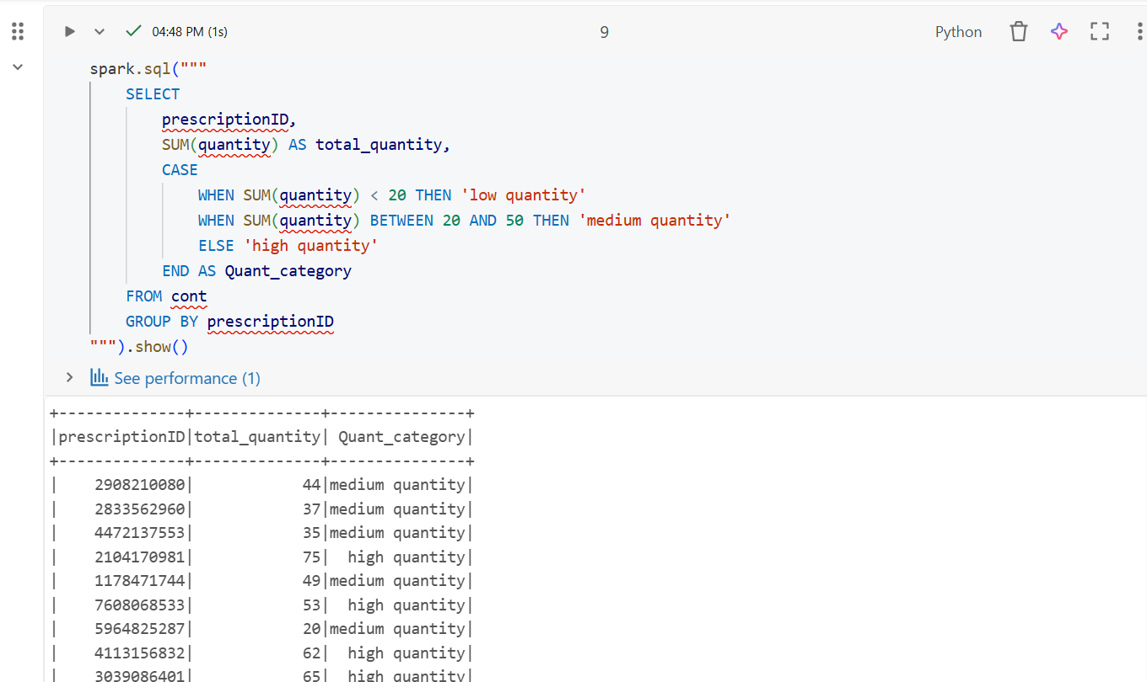

User story :
Find all low-quantity medicines (<1000) with high discounts (≥30%) and high-quantity medicines (>7500) with no discount (0%) in Spot Rx inventory.
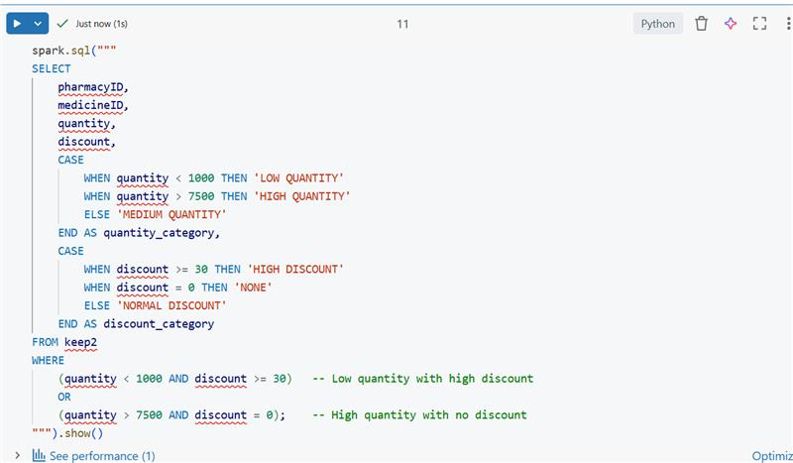
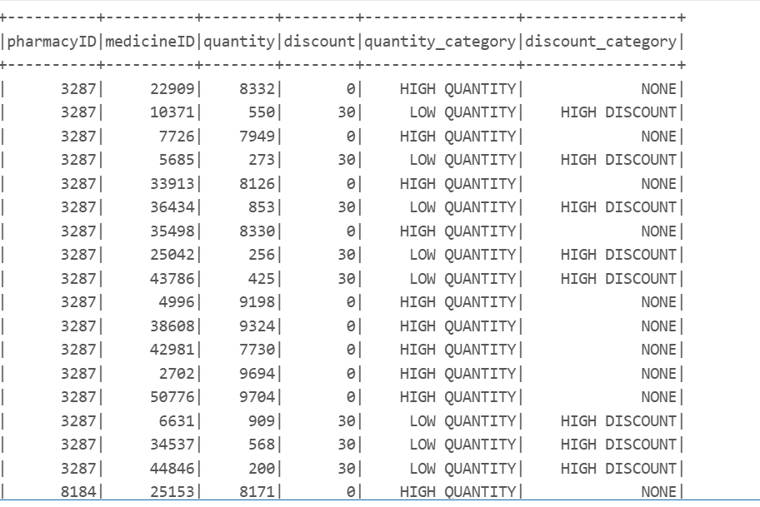

User story :
List all hospital-exclusive medicines that are either affordable (<50% of avg max price) or costly (>2× avg max price), tagging them accordingly.
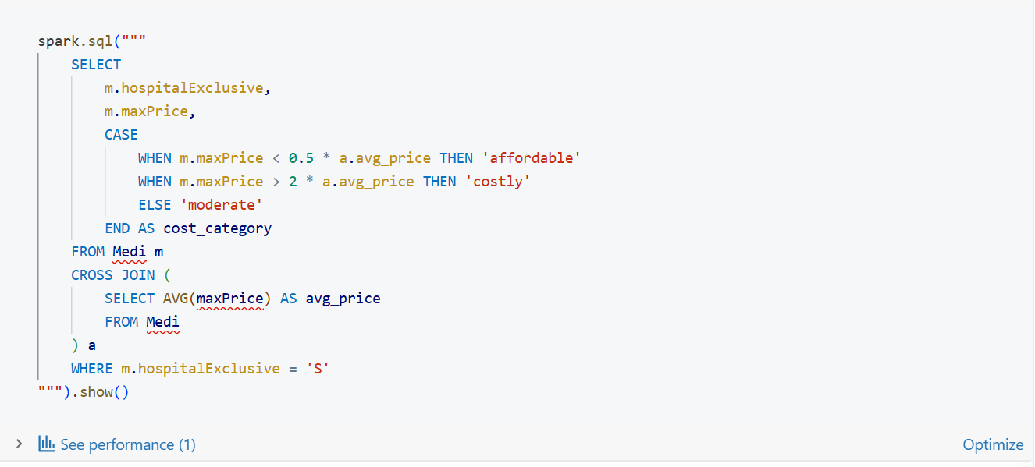
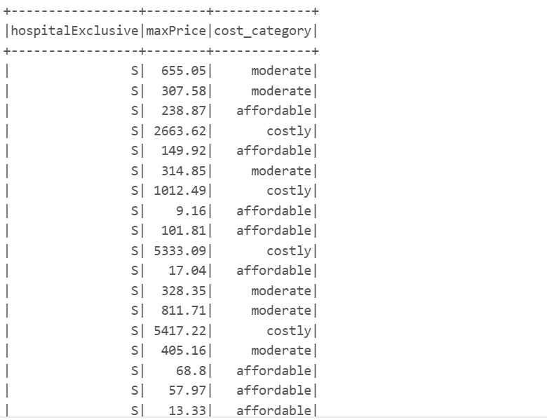

User story:
given an insurance company ID, returns each plan name, the number of treatments claimed under it, and the most claimed disease, ordered by claim count descending."
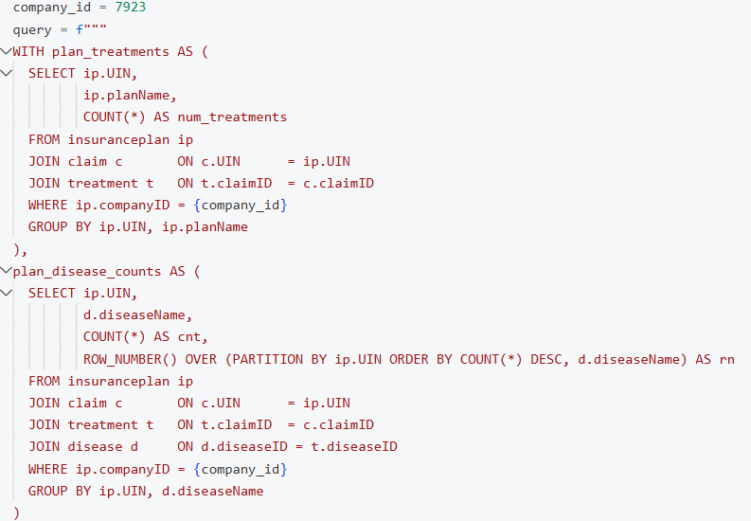
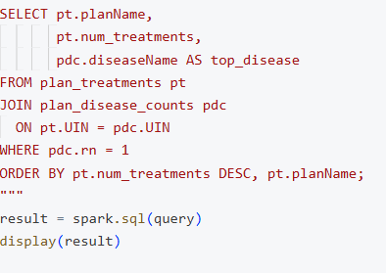
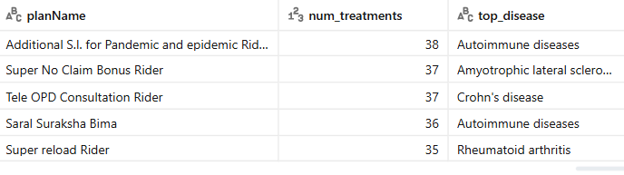

User story:
Acob, as a business strategist, wants to figure out if a state is appropriate for setting up an insurance company or not.
finds the num_patients, num_insurance_companies, and insurance_patient_ratio, should also find the avg_insurance_patient_ratio and if the insurance_patient_ratio of the given state is less than the avg_insurance_patient_ratio then it Recommendation section can have the value “Recommended” otherwise the value can be “Not Recommended”.

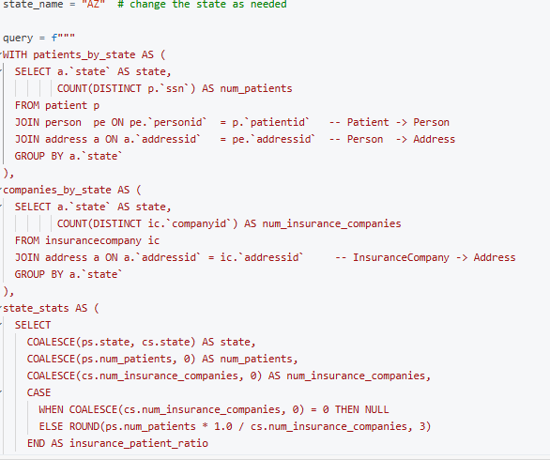
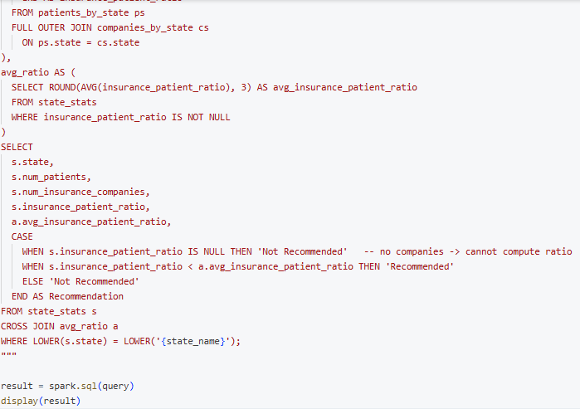

User story:
Trigger that logs inventory changes into Keep_Log with medicineID and quantity difference whenever Keep is updated.
